

**Badger Notes Information and How to Complete Portal Access**

Badger Notes is designed so that the woman can view her maternity record in real-time. Badger Notes is an opt-in service for women who belong to BadgerNet maternity units. This will replace the handheld record and can be used via mobile, tablet, or PC. It is important that women have access to this from the beginning of their pregnancy.

**Setting up portal access to Badger Notes for women**

This usually will have been set up by community admin prior to the woman attending for her booking appointment. If she has had this access before booking, she will have been able to fill out the portal pre-booking questionnaire which populates partner details, next of kin information, and medical history. (See information below for pre-portal booking)

If the woman does not have access to the portal, there are two ways to complete this:

1. To set up portal access, first go into **“Enter new note”** and type in **“portal”**
2. You can also access this inside the smart booking form when completing an antenatal booking:

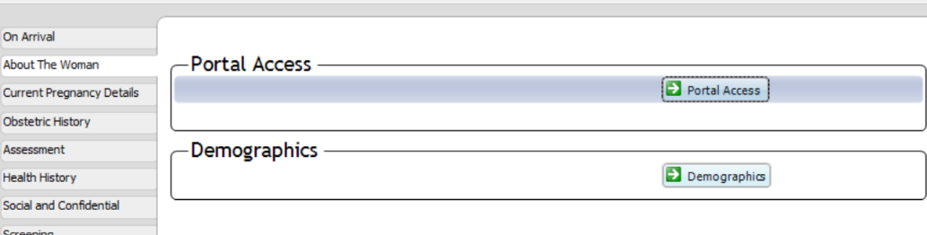

**To complete the portal access form -**

1. Complete all fields within this note

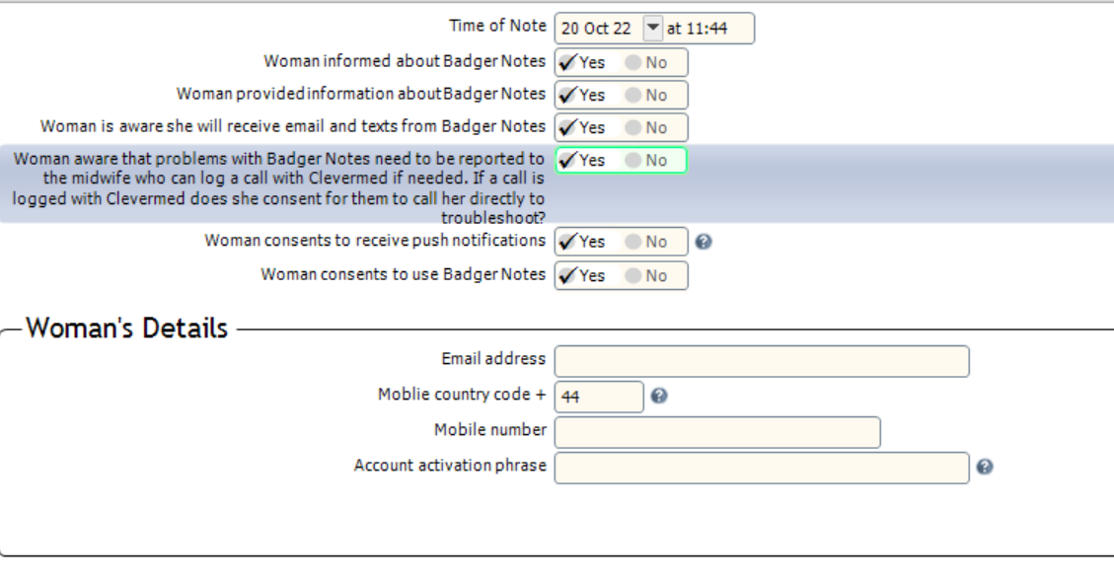

1. Please ensure that the email address and mobile number are correct before proceeding. Ensure that the woman has picked a passphrase that she will remember and knows it is case-sensitive.

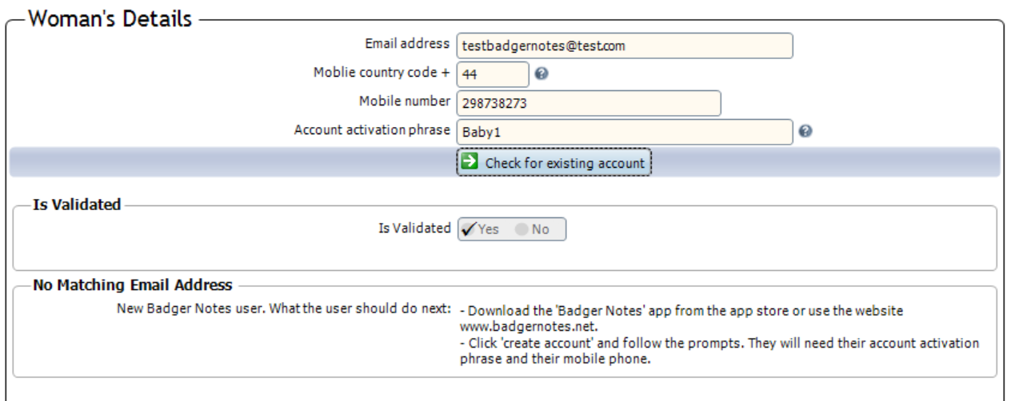

1. Click **“Check for existing account”** to see if she has had an account before. If there are any issues there will be a pop-up at the bottom. As the test woman has not had an account before, you are free to proceed and save. The woman can then download the Badger Notes app or go to [www.badgernotes.net](http://www.badgernotes.net) to create her account and access pre-portal information.

**\*\*\*Please make sure these details are correct and please check this information with the woman as any incorrect spellings and/or missing digits from mobile numbers will delay the woman gaining access to her ‘Badger Notes.’ \*\*\***

**Adding Information to the Personal Timeline and Attaching Leaflets**

There are set lists of information that a woman gets automatically at certain gestations in her “recommended reading” on the app. The personal timeline is how you view this and how you attach additional leaflets.

To view the personal timeline, you can search for this in “enter new note”. Once this is loaded you will see a long list of gestations.

If the gestation is greyed out it means that the woman has passed that gestation. The list of recommended reading you see is what is automatically added for every woman.

**How to attach a leaflet**

If you wish to attach a leaflet to a womans Badger Notes, for example an Anti-D or GBS leaflet you can scroll down on the list to the woman's current gestation. You will see that is not greyed out and you can click into “additional reading”.

When you click into “additional reading” you will get a search box come up for all the leaflets that

u can attach. When you find the leafletyou wish to attach, click on it and click accept and close.

You can then add a message if you wish for the woman to receive. However, this will only come through to her app if you set this up before she reaches 24 weeks gestation. You can tell her she will be able to view her new leaflet in the recommended reading for her current gestation.

Once you save and close the personal timeline, the woman will now be able to view the leaflet you have attached.

**Publishing information to Badger Notes**

For women to see information on their Badger Notes record, it needs to be published to their record by your authorisation. It is important that women who attend a booking, antenatal assessment or a postnatal assessment have their information uploaded.

Please note that any form note identified as **“confidential”** within the BadgerNet record will not be displayed in Badger Notes. This includes items such as previous pregnancies, routine enquiry for domestic violence, clinical notes and confidential social issues.

The following information can be published to Badger Notes after completion:

* Observations Additional Notes (Antenatal and Postnatal)
* Blood Tests, Results and Actions (If abnormal ensure you contact the woman before publishing).
* Microbiology Tests, Results and Actions (If abnormal ensure you contact the woman before publishing).
* Clinical Notes
* Management Plan
* Specialist Review

See examples below and where to find them:

1. Within the booking smart assessment, you can go into **“Recommendations”** and within this, it will enable you to publish the booking to Badger Notes.

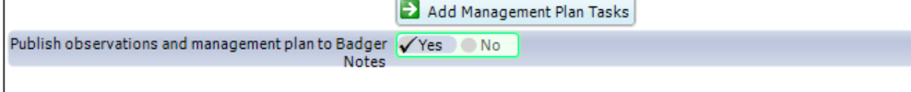

1. After you click yes, it will prompt you to authorise that you want this uploading to the women by putting in your username and password.
2. In the antenatal assessment information within “Observations” you will see it as follows:

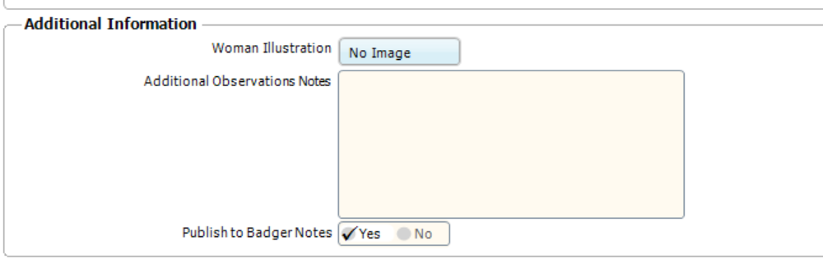

It will again ask for your approval via username and password to upload this to the Badger Notes.

Other forms that can be published include:

**Blood Tests Results and Actions**

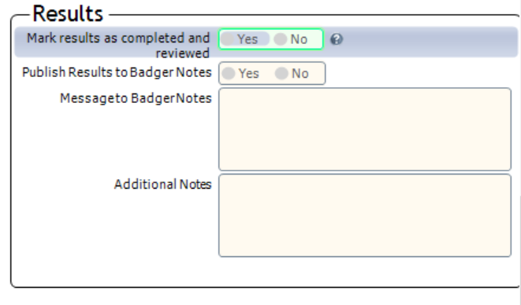

**Microbiological Tests and Actions**

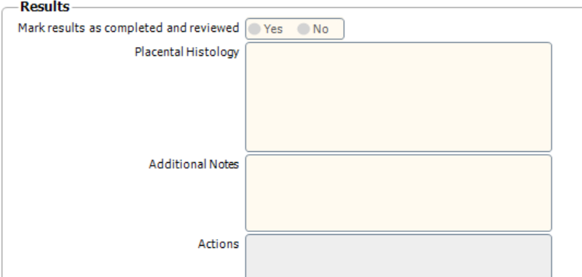

**You can add a comment within these results to publish to the woman. An example could be “all results normal” or “Iron has been requested from your GP”. However, if results need action, ensure you do not rely on this messaging system to be the only way of informing the woman. Ensure you contact the woman first before publishing abnormal results.**

**Management Plans**

If you make corrections or update the management plan, please ensure that you publish this to Badger Notes in the same way as above.

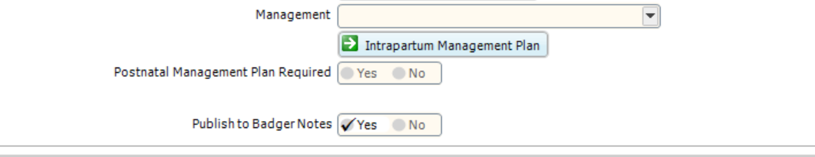

**\*\*\*Important- Please note that any information that is recorded in a woman’s Badger record will be visible to the woman in Badger Notes which includes the above notes if published. Please ensure that any confidential information is recorded in the correct place in Badger, which is the Confidential Social Issues Section. \*\*\***

**Pre-Portal Booking**

Pre-portal will be used for women to input information prior to booking. When the woman logs into her Badger Notes account for the first time, she will be presented with a pre-booking questionnaire to complete via her app/webpage. The plan is for the community admin to complete this access prior to the woman attending. The aim of this is to streamline the booking process as the woman will have done some of the data entry before she arrives for her booking appointment. The information that the woman has completed can be imported into her record during your normal booking process by following the guidance below.

**How to do this?**

1. Collect pregnancy form completed at GP Surgery as normal or view women in booking clinic.

2. Contact the woman to arrange an appointment as normal. If the woman already has an appointment for the GP surgery, please contact her prior to the appointment. When you contact her, you will need to gain consent from her to sign her up for her Badger Notes. The following details will be required to set up portal access:

* **Contact number**
* **Email address**
* **Passphrase** (Patient will need to remember this for signing into her Badger Notes)

3. Discuss with the woman that she can access her pre-portal questionnaire when she first logs in. You can inform her that she will receive access before her booking appointment. This will enable enough time for the community admin to complete the portal access for the woman after the booking information is received.

4. Email the pregnancy form to the community admin as normal and they will set up the portal access in due course. You are able to see within the record if portal access has been created if a woman contacts you regarding this. You can see this within **“Full Notes”**.

**Transferring Pre-portal booking information into record**

1. Commence **“Antenatal Booking”** on BadgerNet

2. Select **‘Portal pre-booking’** from the **“On Arrival”** section.

3. You should see the information already entered by the woman. Check the information is correct and scroll down to the bottom of the form to where it says **‘Populate information’**. Click on the button to transfer this information into the record. Click save and close. Once transferred, the information will be locked and the woman will not be able to edit any information in this form.

**How to check what information a woman is seeing in her app**

Should you need to check the exact information that a woman is seeing in Badger Notes, the reports she has access to are available in the BadgerNet record on the left-hand menu. Scroll down to the section which says **“Badger Notes”** and click on reports there.

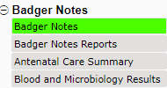

In the **“Badger Notes”** tab, you can easily see an overview of portal access, timeline information and reading lists. You can also see if the woman has accessed any leaflets you have provided in this view.

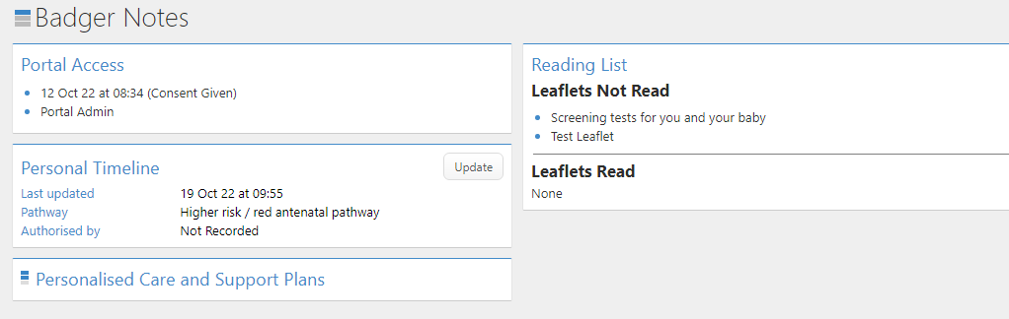

Within **“Badger Notes Reports”** all reports have ‘click through’ functionality so if you need to jump to a specific data item featured on the report, just click on the field on the report and the BadgerNet form will open. This section provides access to text-based reports such as the “**Welcome Report”** and **“Antenatal Booking Summary”**. This is what the woman will see:

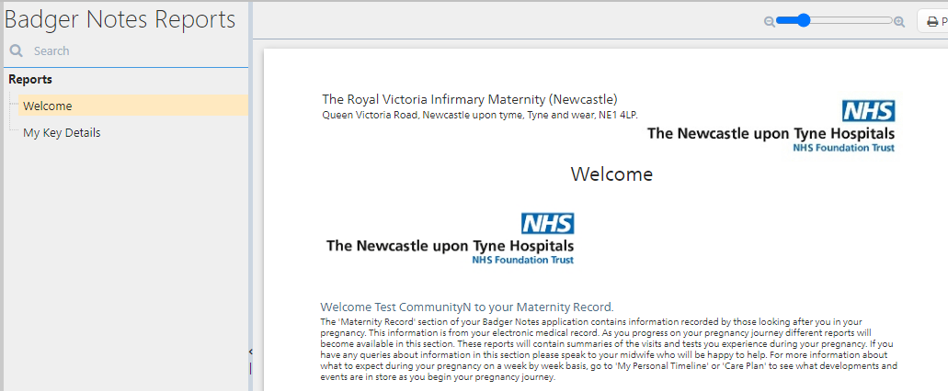

**Antenatal Care Summary**

Antenatal Care Summary – this is a tabular report, reminiscent of the ‘**Notes During Pregnancy**’ feature which shows antenatal care events in chronological order. The columns are populated if relevant information has been published to Badger Notes. Clicking on the row loads a full report detailing events that took place.

**Support Conversations**

This change allows women using Badger Notes to record a birth plan or antenatal and postnatal support conversation, which are then visible to the midwife in BadgerNet on her next antenatal or postnatal visit.

What the pregnant person sees:

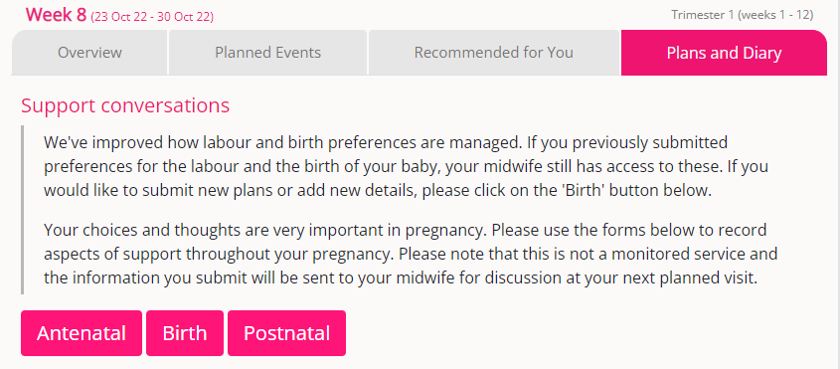

What the woman can enter:

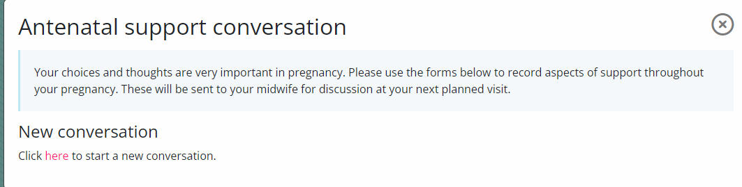

When the woman starts a new conversation, she can write her thoughts, comments and questions regarding her plan of care, what matters to her and any questions she may have. There are also sections for emotional health and lifestyle. When the woman saves this, it can be seen within her record. It is made clear to the woman that the midwife will not have access to this until they next see you so that urgent information is not left to be actioned.

**What the midwife/team can see and enter**

In an antenatal assessment form in BadgerNet the antenatal support conversations are visible in the right-hand pane at the bottom, ditto postnatal support conversations in a postnatal assessment. Support conversations waiting to be reviewed are marked with an orange exclamation icon. Conversations that have been reviewed by the midwife are marked with a green tick.

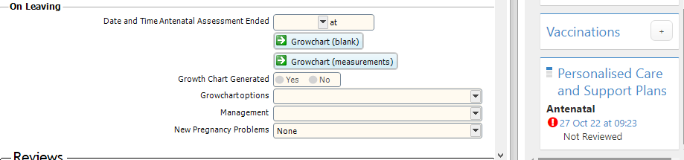

These can also be seen within the **“Badger Notes”** section on the main left-hand menu as below.

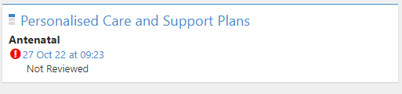

If you click to review this, it will load the entire form and you can discuss this with the woman whilst she as at her appointment with you.

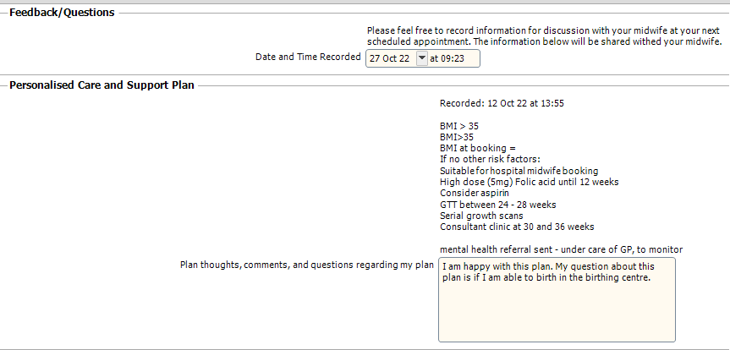

At the end, there is a box for midwife feedback which you can do if the woman is not present and has asked you to respond to this.

If you require any further support or training please email [Nuth.badgernetmaternitysupport@nhs.net](mailto:Nuth.badgernetmaternitysupport@nhs.net)



Check List for Badger Notes

* Contact woman at booking and check If she received Badger Notes leaflet
* Explain about Badger Notes
* Ensure the date of birth, email address and telephone number on the form are correct
* Ensure she knows her passphrase
* Inform her 48 hours prior to her booking that the portal will be available
* Inform her about the pre-portal booking form and ask her to complete this
* Email completed form to community admin
* At the booking, import the pre-portal questionnaire if it has been completed

If no access to portal:

* Complete the portal access as above
* Ensure the woman’s email/telephone number and passphrase are correct
* If unable to access, the woman needs to contact [nuth.badgernetmaternity.support@nhs.net](mailto:nuth.badgernetmaternity.support@nhs.net)